sterling, NEBRASKA

$315,000 available for an

Owner-Occupied Housing Rehabilitation Program

OFFERED BY

the Village of Sterling partnering with sendd & NDED
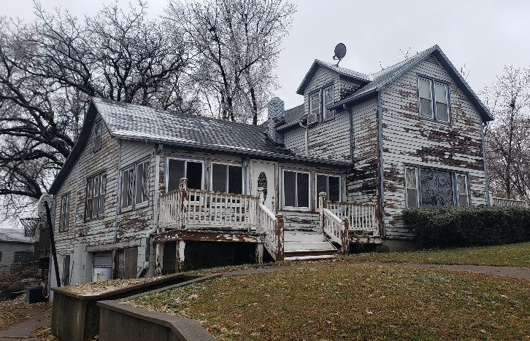
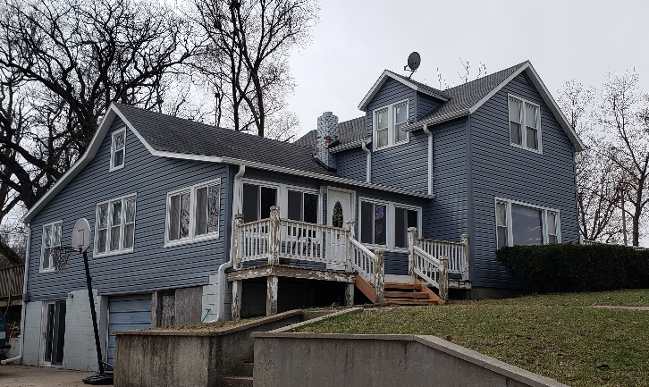
Need more information?
Contact SENDD or your Village
Office for an application or more
information!
Nichole Jones
Housing Specialist
njones@sendd.org
Southeast Nebraska
Development District (SENDD)
7407 O Street
Lincoln, NE 68510
PHONE: (402) 475-2560
FAX: (402) 475-2794
Income Qualifications
- Applicants at or below 80% of the median household income of Johnson County, NE, adjusted for family size may be eligible.
Family Size Income Limit
1 $44,050
2 $50,350
3 $56,650
4 $62,900
5 $67,950
6 $73,000
7 $78,000
8 $83,050
AFTER
Property Eligibility/ Amount of Assistance
• Housing units within municipal limits of Sterling are eligible
- There are certain eligibility requirements, including
income, assets, and homeownership. Mobile homes and rental properties are not eligible for participation in the program.
- Financial assistance per household generally ranges from $5,000-$23,000 for each unit.
- The maximum amount of assistance is $24,999.
- If a home cannot be determined to meet basic standards with $24,999 in assistance, the unit will not qualify for assistance.

The Village of Sterling has established an Owner-Occupied Housing Rehabilitation Program with funding awarded from the Nebraska Department of Economic Development. Eligible homeowners may receive assistance to make structural, mechanical, electrical, weatherization, and plumbing improvements to their homes.

Owner-Occupied Housing Rehabilitation Program
BEFORE

