**What is an Owner-Occupied Housing Rehabilitation Program?**

The Village of Sterling has received funding through the Nebraska Department of Economic Development (NDED) to establish an Owner-Occupied Housing Rehabilitation Program. Eligible homeowners may receive assistance to make structural, mechanical, electrical, weatherization and plumbing improvements to their homes.

**How do I know if I’m eligible?**

There are certain eligibility requirements, including income, assets, and homeownership. Mobile homes and rental properties are not eligible for participation in the program.

**Will I have to repay the assistance?**

Conditional Grant: Households will qualify for a 100% Conditional Grant that will be forgiven after 5 years if the owner does not move, sell or rent their property within the 5-year affordability period.

**How much assistance is available?**

Financial assistance per household generally ranges from $5,000 - $23,000 per unit. The maximum per housing unit is limited to $24,999. This limit unfortunately may exclude certain homes from participating in the program. For example, if a home will not meet basic standards after injecting $24,999 in assistance, then the home will not be eligible for the program.

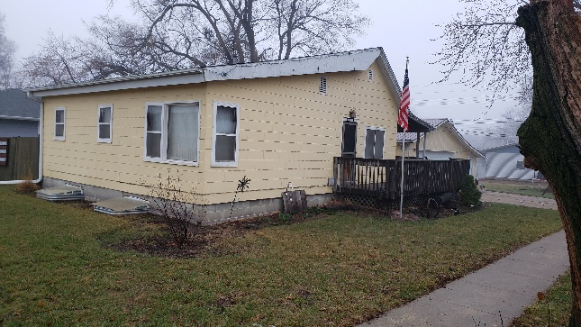

**What repairs are ELIGIBLE?**

Eligible repairs are those that will add approximately twenty (20) years to the life expectancy of your home, including:

* Structural-Foundation, Roof, etc.
* Mechanical-Furnace, Air Conditioning
* Water Heater
* Electrical - Wiring, Fuse Boxes
* Plumbing
* Weatherization- Windows, Doors,  
  Insulation, Siding, Etc.
* General Maintenance- Kitchens, Bathrooms, Etc.
* Handicapped Accessibility- Ramps, Bathrooms, Etc.
* Relieve Overcrowding
* Safety or Code Deficiencies
* Lead-Based Paint Mitigation

**What repairs are NOT ELIGIBLE?**

* Detached Garages & Outbuildings
* New Driveways & Sidewalks
* Window Air Conditioning Units
* New Decks & Patios
* Landscaping & Fences
* Jacuzzis, Hot Tubs & Spas
* Kitchen Appliances
* Reimbursement for Repairs **not** completed by the Program.

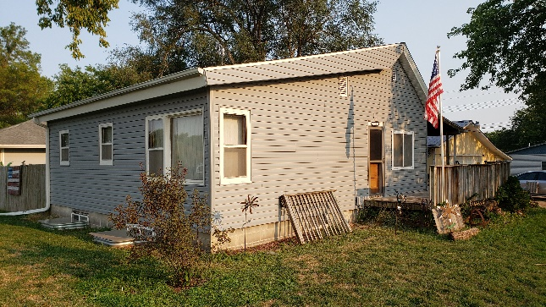

**What are the annual household income limits for eligibility?**

**2022 Income Limits**

|  |  |
| --- | --- |
| **Family**  **Size** | **Maximum Gross Annual Household Income** |
| 1 | **$44,050** |
| 2 | **$50,350** |
| 3 | **$56,650** |
| 4 | **$62,900** |
| 5 | **$67,950** |
| 6 | **$73,000** |
| 7 | **$78,000** |
| 8 | **$83,050** |

The Fair Housing Act protects people from discrimination when they are renting, buying, or securing financing for any housing. The prohibitions specifically cover discrimination because of race, color, national origin, religion, sex, disability and the presence of children.

Un mensaje de servicio público del Departamento de Vivienda y Desarrollo Urbano de los Estados Unidos en asociación con la Alianza Nacional de Equidad de Vivienda. La Ley Federal de Equidad de Vivienda prohíbe la discriminación por motivos de raza, color, religión, nacionalidad, sexo, situación familiar o discapacidad. Para más información, visita www.hud.gov/fairhousing.



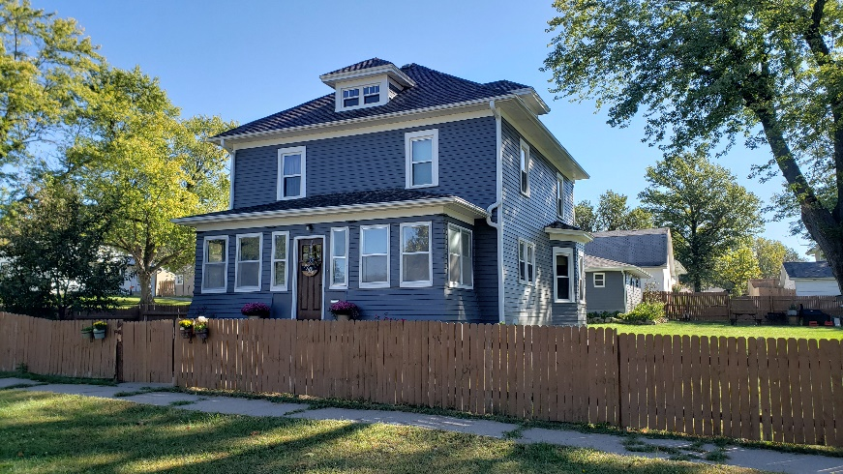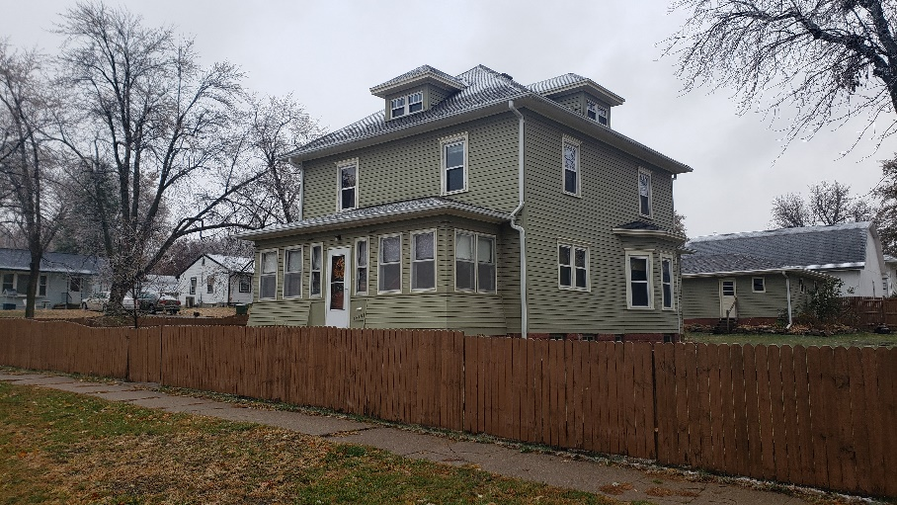

**Who do I contact for more information?**

**Nichole Jones – Housing Specialist**

Southeast Nebraska Development District

7407 O Street

Lincoln, NE 68510

Phone: (402) 475-2560

Fax: (402) 475-2794

Email: [njones@sendd.org](mailto:njones@sendd.org)

Don’t miss out on a chance to make those improvements on your house that you have not been able to accomplish on your own.

Reduce energy costs and increase the value of your home with a grant!

**What is the deadline?**

All full applications received during a "cycle” will be reviewed together and rated on a priority rating scale. Applicants not selected in one round will be automatically considered in subsequent rounds (if funding is available) and will be notified, in writing, of such action.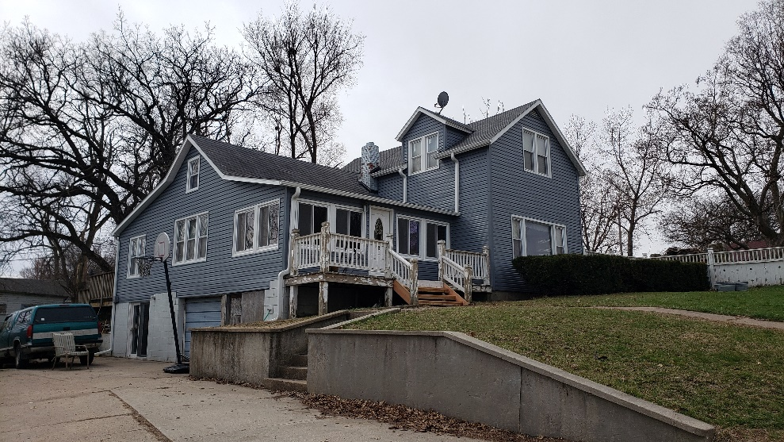

**I’m interested, so where can I pick up an Application Form?**



Sterling Owner Occupied Housing Rehabilitation Program Applications are available at the following location:

**Contact SENDD or your Village Office for an application or more information!**

Sterling   
Owner-Occupied Rehabilitation

Housing Program

