STERLING, NEBRASKA

Owner-Occupied Housing Rehabilitation Program

OFFERED through

THE community development block grant program
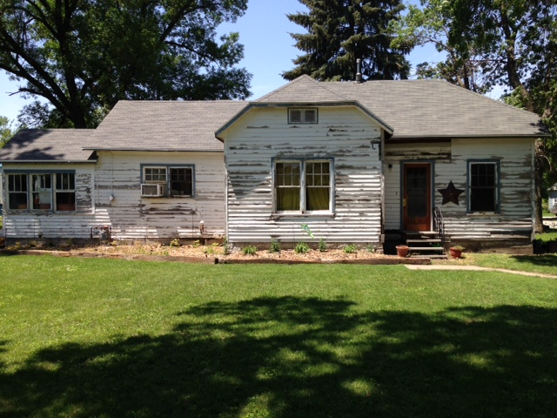
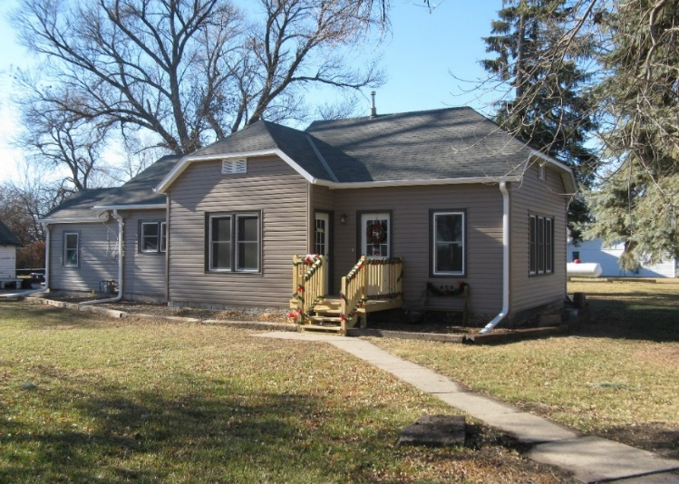

The Village of Sterling has received funding from the Nebraska Department of Economic Development (NDED) to establish an Owner-Occupied Housing Rehabilitation Program. Eligible homeowners may receive assistance to make structural, mechanical, electrical, weatherization, and plumbing improvements to their homes.

Need more information?
Cole Hartgerink, Housing
Program Specialist
Southeast Nebraska
Development District
(SENDD)
7407 O St.
Lincoln, NE 68510
PHONE: (402) 475-2560
FAX: (402) 475-2794
EMAIL:
chartgerink@sendd.org

Property Eligibility/ Amount of Assistance
• Housing units within the village limits of Sterling are eligible to participate in this program.
- There are certain eligibility requirements, including
income, assets, and homeownership. Mobile homes and rental properties are not eligible for participation in the program.
- Financial assistance per household generally ranges from $5,000-$23,000 for each unit.
- The maximum amount of assistance is $24,999.
- If a home cannot be determined to meet basic standards with $24,999 in assistance, the unit will not qualify for assistance.

Income Qualifications (2021 Limits)
- Applicants at or below 80% of the median household income of Johnson County, NE, adjusted for family size may be eligible.
1 person $39,400
2 person $45,000
3 person $50,650
4 person $56,250
5 person $60,750
6 person $65,250
7 person $69,750
8 person $74,250

Owner-Occupied Housing Rehabilitation Program
AFTER
BEFORE

