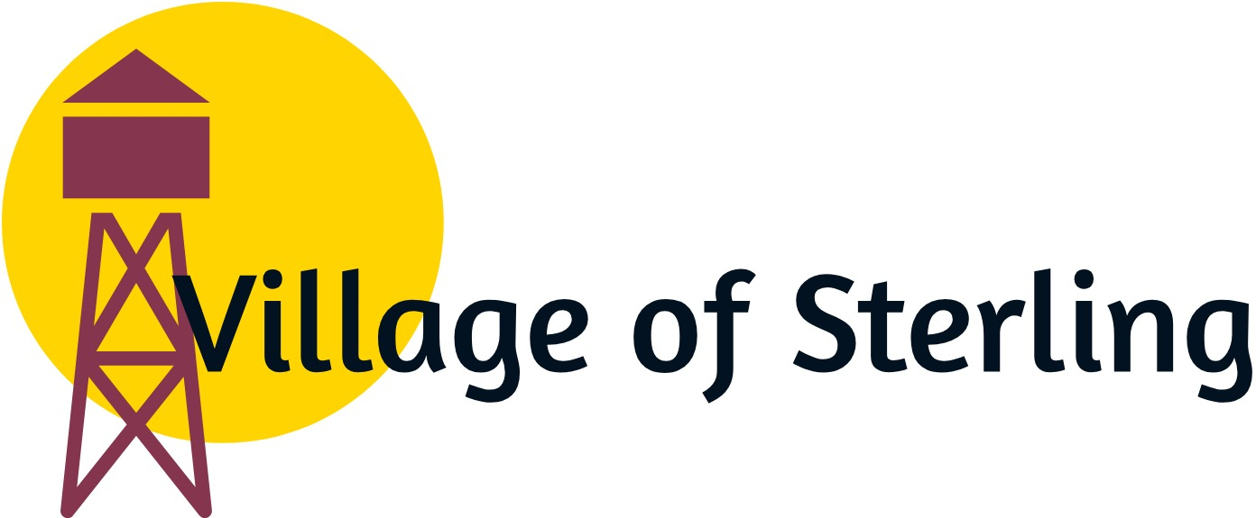

REQUEST FOR FUTURE AGENDA ITEM

If you have a specific topic that you would like the Village Board of Trustees to discuss at a future meeting, please list your name, address, telephone number, and the specific topics. The item will be reviewed and possibly scheduled for a future meeting, or forwarded to Village staff for appropriate action. If wanting on the next board meeting, form must be received by the Wednesday prior to board meeting, which falls on the second Tuesday of the month.
Name: _____________________________________________________________
Address:______________________________________________________________________________________________________________________________
Telephone #:________________________________________________________
Date of Request:_____________________________________________________
Description of Requested Topic: _____________________________________________________________________________________________________________________________________________________________________________________________________________________________________________________________________________________________________________________________________________________________________________________________________________________________________________________________________________________

